Paper Pilot

Design Document

Alex Vucicevich

ICS3UI

Game Description

Paper Pilot, the creation of a bored high school student doodling the adventures of a courageous pilot returning home from a dangerous mission, only to find that his trials have only just begun. Thousands upon thousands of similarly doodled bullets continuously bombarding him from every angle in an attempt to stop him from completing his mission, to return home. Paper Pilot has to survive with his pure piloting skills and maybe, some luck.

In the Game Paper Pilot, the user controls a ship that moves freely through a bombardment of enemy bullets. The game itself is inspired by “Bullet Hells”. Bullet Hells are challenging games where the user must survive through a barrage of enemy bullets without being hit by projectiles. Paper Pilot has the same concept but has very contrasting design choices compared to other bullet hells. All images in Paper Pilot are hand drawn to represent actual hand writing and actual drawings from the imagination of a highschool student.

The objective of the game is to get through ten levels of increasing difficulty without losing the lives you entered the level with. If the user loses all three lives, “Paper Pilot” dies and a depressing game over screen appears. No checkpoints, no revives and no trying again. The user must return all the way back to level one to retry the ten level struggle.

Even though this sounds challenging, the “Paper Pilot” is one smart pilot! In between levels, the user's ship will regain their three lives for the next level of bullet onslaught. If the user is skilled enough, and does not lose a single life in an entire level, they will gain an extra life on top of the three current lives that they have.

The user will be able to go through any level they want in the game through a level select menu. Here the user can practice their “Piloting” skills in various challenging levels that will be seen through the main story mode of the game. The user will still have the standard three lives during these levels, however will not progress as they would through the story mode, as it is just more of a fun practice mode as preparation for the assault of bullets they will face in story mode.

It is up to you, the user, the “Paper Pilot” to return home safe and sound using your quick reflexes and insane piloting skills. Future generations will tell stories about the trials of the Paper Pilot, but only if he returns home in one piece.

Instructions for Play

**1. Starting the Game:**

To begin playing Paper Pilot, open the python file “Paper Pilot.py” and hit the F5 key

**2. Menu Screen / Starting Options:**

The opening screen will appear shortly after, giving the player the choice between three different buttons which consist of: “Play (1)”, “Help(2)” and “Level Select(3)”

**3. What Each Menu Button Does:**

*After you select a button, you will be brought to one of four different screens.*

3.1: Story

The “Story” button leads you to the actual game. (Instructions on how to play the game will be in section 4)

3.2: Help

The “Help” button leads the user to a quick help screen on keyboard and mouse controls for the game. Information such as what the bullets look like and what happens when you get hit by certain bullets. (Instructions on how to play game in section 4)

3.3: Level Select

The “Level Select” button brings you to a screen where you can choose to play any level in Paper Pilot (Levels 1 - 10). After clicking a button, click

the “Play Selected Level” button at the bottom of the screen to play the desired level.

**4. Controls for the game/Controlling the player**

4.1: Keyboard Controls

4.1.1: Q = Quit Game.

By pressing Q, the game will end.

4.2.2: P = Pause Game.

By pressing the pause button, two buttons will appear. “Continue” which resumes the game and “Quit” which has the same function as pressing the Q button

4.2: Mouse Controls

4.2.1: Movement

By moving your mouse, you can move the ship. Dodge bullets by moving your mouse.

4.2.2: Left Click

In order to press buttons, the user uses the mouse’s “Left Click” in order to activate the buttons.

**5. Enemy Details:**

5.1: Blue Bullets

If the user hits a blue bullet, the player loses a life.

5.2: Red Bullets

If the user hits a red bullet, the player dies, ending the game

**6. Playing the Game / Game Objectives / Game Screen:**

6.1: On Screen Information:

*While playing paper pilot, the user will see a variety of images showing the user information.*

6.1.1: Level Number:

The level number that the player is currently on is displayed in the center of the screen.

6.1.2: Number of Lives:

The number of lives the player currently has is displayed on the bottom left corner of the screen.

6.2: Game Objectives:

The objective of “Paper Pilot” is simple:

* Don’t get hit by projectile bullets
* Don’t lose all your lives
* Make it through all 10 levels to make it back to earth.

Sketch of Game Screens

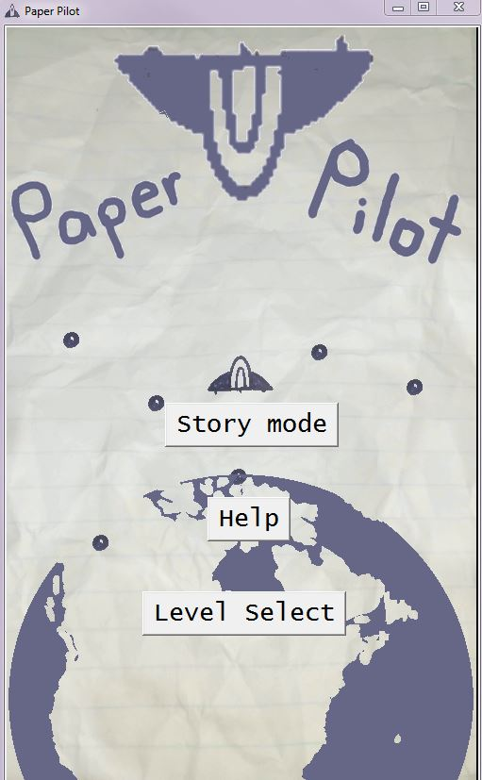

*Main Menu Screen*

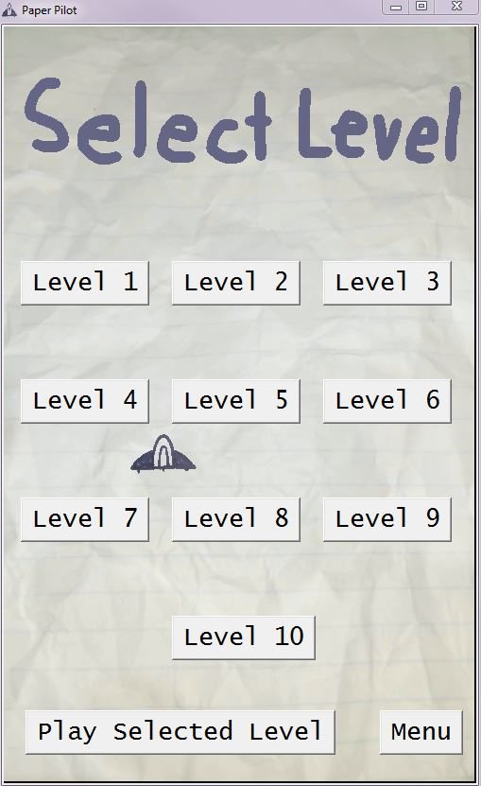

*Select Level Screen*

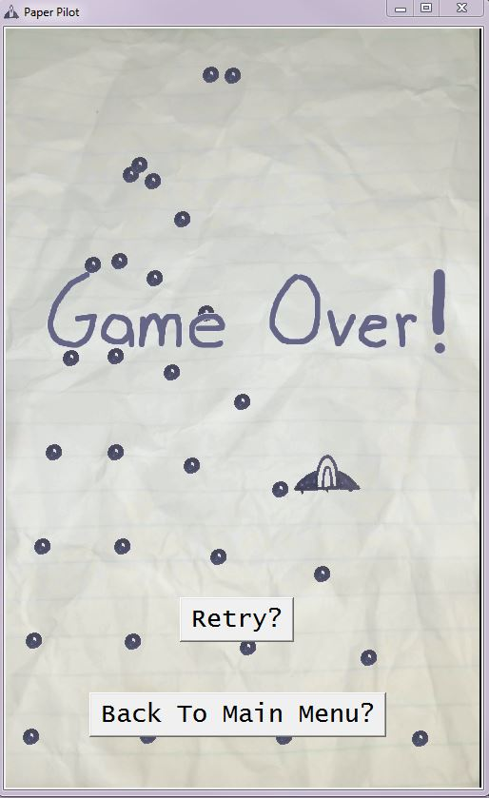

*Game over Screen*

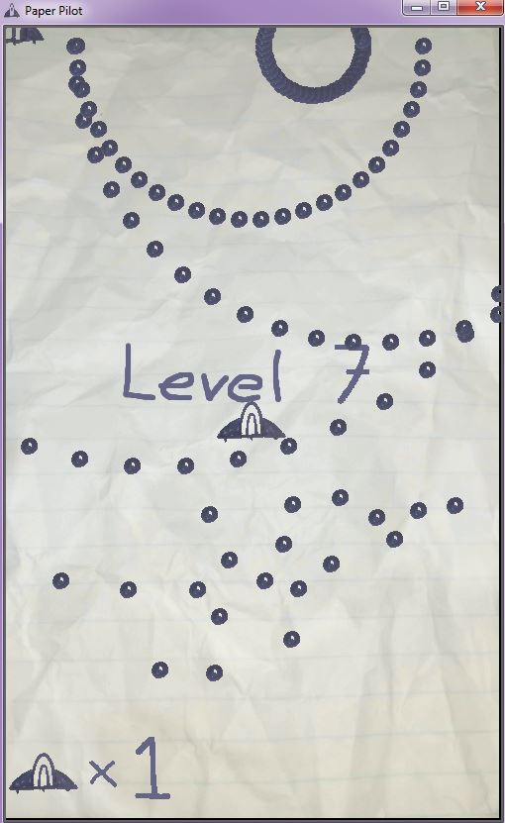

*Actual Gameplay footage*